SignalBridge Project Intelligence

1. Introduction
SignalBridge is a technology company managing multiple large client projects. Project information such as updates, risks, decisions, and changing requirements is distributed across different teams and business systems.
The proposed AI system will analyze this information, identify important project signals, and prepare a situation brief for project leaders.
The main challenge is ensuring that the AI does not make conclusions from isolated, outdated, incomplete, or unsupported information.

2. Problems Identified
The trial identified six major problems:
- Isolated information — The AI may treat a single comment as a major project risk.
- Disconnected information — The AI may fail to connect related information shared by different teams.
- Outdated information — The AI may use information from earlier discussions even after the situation has changed.
- Multiple information sources — Relevant information is spread across different business systems.
- Insufficient evidence — The AI may recommend an action without enough supporting evidence.
- Different AI capabilities — Collecting information, assessing risks, and preparing a brief require different tasks.

3. Proposed Solution

We recommend an evidence-based, multi-stage AI system.

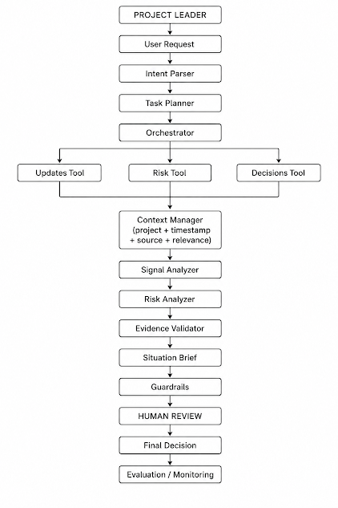

Intent Parser and Task Planner

The Intent Parser understands what the project leader is asking.

The Task Planner then determines what information needs to be collected and what analysis needs to be performed.

Orchestrator

The Orchestrator coordinates the different AI stages and tools.

It ensures that information is collected before analysis and that evidence is validated before the final brief is generated.

Tools and Business Systems
The system uses tools/APIs to retrieve information from different business systems, such as:
- Project updates
- Risk information
- Project decisions
- Changing requirements
This provides the AI with current project information instead of relying only on the model's existing knowledge.

Context Manager
The Context Manager keeps relevant information together and checks:
- Project
- Team
- Timestamp
- Source
- Relevance
- Current status
This helps prevent the AI from using outdated information.
Signal Analyzer
The Signal Analyzer identifies important project signals such as:
- Risks
- Changes
- Decisions
- Dependencies
- Delays
A single comment should not automatically be treated as a major risk.

Risk Analyzer
The Risk Analyzer connects information from different teams and determines whether the signals together indicate a significant risk.
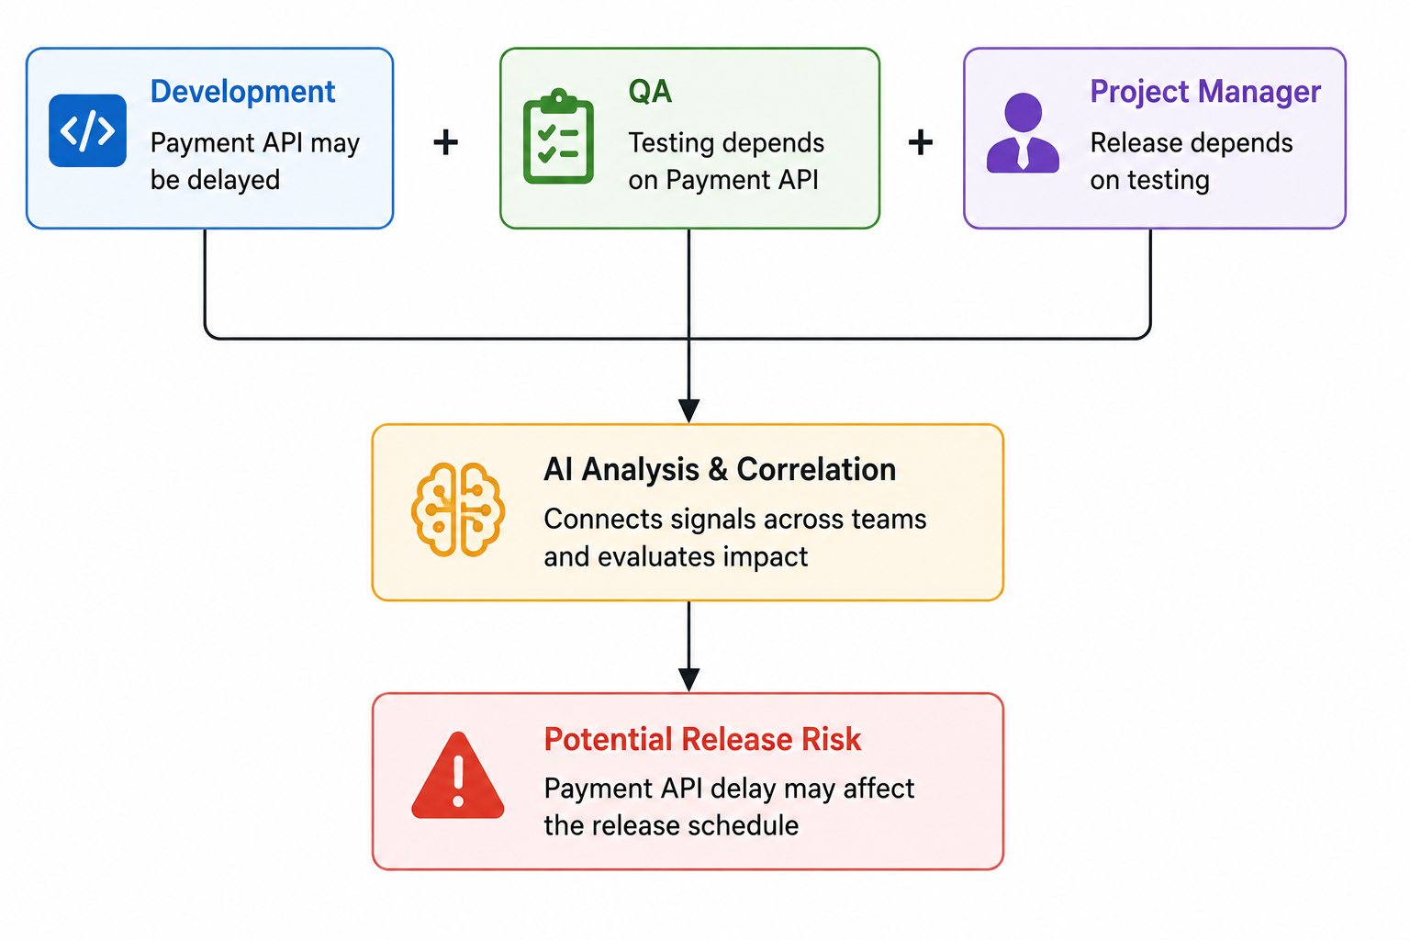

Evidence Validator
Before making an important conclusion or recommendation, the system checks whether sufficient evidence exists.
If the evidence is weak or incomplete, the AI should report uncertainty rather than presenting the conclusion as fact.

Situation Brief
The final briefing component produces a concise situation brief containing:
- Current status
- Important signals
- Identified risks
- Supporting evidence
- Confidence/uncertainty
- Recommended actions when sufficient evidence exists

4. AI Controls and Guardrails
The system uses the following controls:
- Evidence-based conclusions:
Important risks and recommendations must be supported by retrieved evidence.
- Cross-source verification:
Related information from multiple teams should be considered before identifying a significant risk.
- Recency checking:
The system checks timestamps and current status to reduce the use of outdated information.
- Uncertainty handling:
When evidence is insufficient, the AI should clearly indicate this instead of making an unsupported claim.
- Human approval:
Consequential recommendations require human review before action.

5. Human-in-the-Loop

The AI acts as a decision-support system, not the final decision-maker.
Human review is important because the AI may:

- Misinterpret isolated comments
- Miss relationships between information
- Use outdated information
- Lack complete information
- Make recommendations without sufficient evidence
Therefore, the final decision remains with the project leader.

6. Demonstration
A simple demonstration can follow this flow:
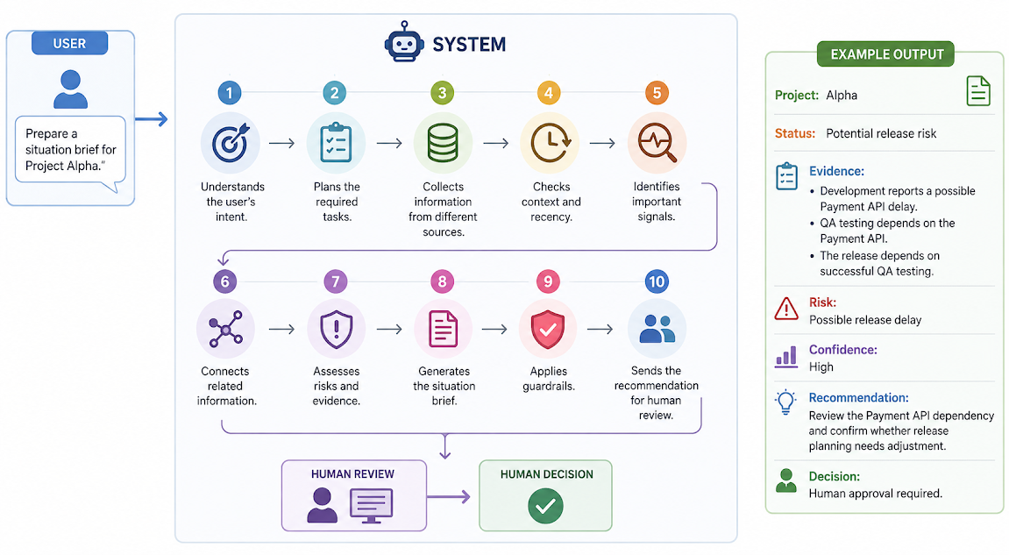

7. Conclusion
The proposed SignalBridge system uses a multi-stage, evidence-based AI architecture to collect project information, understand context, connect signals, assess risks, validate evidence, and generate a situation brief.
The architecture directly addresses the problems identified in the trial, particularly isolated information, disconnected signals, outdated information, multiple data sources, and insufficient evidence.

